Human Iris Recognition
And Face Emotion Detection

Author by
K. PANDI KUMAR M.E.,
Dr. Paul’s Engineering College
Co-author By Co-author By
n.venkatesan, M.E. G.SethuramalingamM.C.A, M.E.(phd),
Assistant Professor Assistant Professor
Department of Computer Science Department of Computer
and Engineering, Applications,
st.peter university Easwari Engineering College.

Abstract—Iris recognition imaging constraints are receiving increasing attention. There are several proposals to develop systems that operate in the visible wavelength and in less constrained environments. These imaging conditions engender acquired noisy artifacts that lead to severely degraded images, making iris segmentation a major issue. Having observed that existing iris segmentation methods tend to fail in these challenging conditions, I present a segmentation method that can handle degraded images acquired in less constrained conditions. I offer the following contributions: 1) to consider the sclera the most easily distinguishable part of the eye in degraded images, 2) to propose a new type of feature that measures the proportion of sclera in each direction and is fundamental in segmenting the iris, and 3) to run the entire procedure in deterministically linear time in respect to the size of the image, making the procedure suitable for real-time applications.

Introduction
1 PROJECT OVERVIEW:
The purpose of ‘Iris Recognition’, a biometrical based technology for personal identification and verification, is to recognize a person from his/her iris prints. In fact, iris patterns are characterized by high level of stability and distinctiveness. Each individual has a unique iris; the difference even exists between identical twins and between the left and right eye of the same person. The first step of our project consists of images acquisition. Then, the pictures’ size and type are manipulated in order to be able subsequently to process them. Once the preprocessing step is achieved, it is necessary to localize the iris and unwrap it. At this stage, I can extract the texture of the iris using Haar Wavelets. Finally, we compare the coded image with the already coded iris in order to find a match or detect an imposter.

Image acquisition is considered the most critical step in our project since all subsequent stages depend highly on the image quality. In order to accomplish this, I used a CCD camera. I set the resolution to 640x480, the type of the image
to jpeg, and the mode to white and black for greater details.

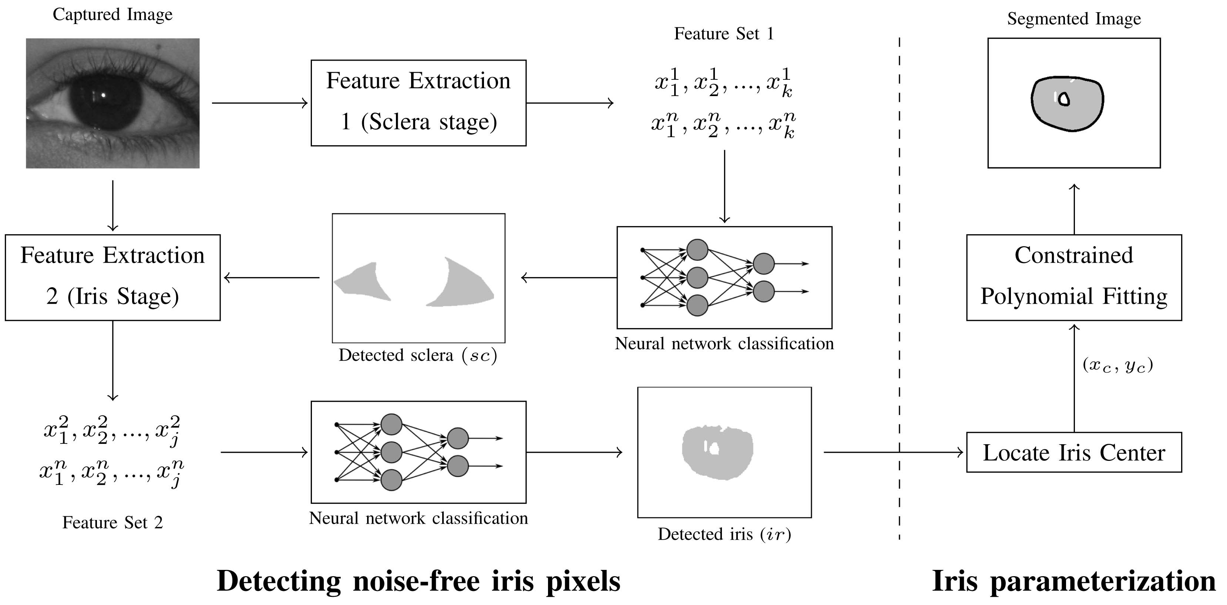

Furthermore, I took the eye pictures while trying to maintain appropriate settings such as lighting and distance to camera. The pigmentation of the human iris consists mainly of two molecules: brown-black Eumelanin (over 90 percent) and yellow-reddish Pheomelanin. Eumelanin has most of its radiative fluorescence under the VW, which—if properly imaged—enables the capture of a much higher level of detail, but also of many more noisy artifacts, including specular and diffuse reflections and shadows. Also, the spectral reflectance of the sclera is significantly higher in the VW than in the NIR and the spectral radiance of the iris in respect of the levels of its pigmentation varies much more significantly in the VW than in the NIR. All of these observations justify the need for specialized segmentation strategies, as the type of imaged information is evidently different. Furthermore, traditional template and boundary-based iris segmentation approaches will probably fail, due to difficulties in detecting edges or in fitting rigid shapes. These observations were the major motivation behind the work described in this paper: the development of an iris segmentation technique designed specifically for degraded iris images acquired in the VW and unconstrained scenarios.

2 RELATED WORK:
Processing in the proposed method consists of four stages. These stages are image normalization, image segmentation, feature extraction and similarity measurement. In the normalization step, iris image is converted to 256 gray level images.

Second stage is image segmentation. In this stage, two processes are carried out. Those are sclera localization and iris localization. The assumptions for the segmentation process are that the sclera is darker than the iris and the iris is darker than the sclera. Another assumption is that sclera and iris have circular shape with different centers. In many cases the upper and lower part of the iris is often occluded by eyelids. In order to determine the pupil location, the image of an eye is divided into 8x8 regions. The mean intensity from each region is calculated and the lowest mean intensity value is used as a threshold.

3 OBJECTIVE
- To consider the sclera the most easily distinguishable part of the eye in degraded images
- To propose a new type of feature that measures the proportion of sclera in each direction and is fundamental in segmenting the iris
- To run the entire procedure in deterministically linear time in respect to the size of the image, making the procedure suitable for real-time applications.

4 EXISTING SYSTEM:
The iris recognition method summarizes several recently published works about iris imaging constraints and acquisition protocols. Less Constrained Image Capturing is a major example of engineering an image acquisition system to make the recognition process less intrusive for subjects. Iris Segmentation Method used in “Preprocessing” lists the image preprocessing techniques used before segmentation. Feature Extraction Stages to detect the sclera and noise-free iris pixels. Due to performance concerns, I decided to evaluate only those features that a single image scan can capture. Sclera Stage examining degraded eye images, the iris region can be hard to discriminate, even for humans. Also, the sclera is much more naturally distinguishable than any other part of the eye, which is a key insight: Our process detects pixels that belong to the sclera and, later, we exploit their mandatory adjacency with the iris in order to find the iris.

4.1 EXISTING SYSTEM DISADVANTAGES:
- The NIR wavelength is particularly hazardous because the eye does not instinctively respond with its natural mechanisms
- In the existing Non-ideal iris images can significantly affect the accuracy of iris recognition systems for two reasons
1) They cannot be properly preprocessed by the system
2) They have poor image quality

5 PROPOSED SYSTEM:
I propose robust eye iris detection. Irises are detected even when the images have obstructions, visual noise and different levels of illumination. Lighting reflections, eyelids and eyelashes obstructions are eliminated. Images with narrowed eyelids or eyes that are gazing away are also accepted.

To propose a new type of feature that measures the proportion of sclera in each direction and is fundamental in segmenting the iris.

I also proposed Automatic interlacing detection and correction.

I propose constrained polynomial fitting procedure that naturally compensates for classification inaccuracies parameterizes the pupillary and scleric iris borders.

5.1 METHODOLOGY:
- The initial phase is further subdivided into two processes: detecting the sclera and detecting the iris. The key insight is that the sclera is the most easily distinguishable region in nonideal images.
- Next, I exploit the mandatory adjacency of the sclera and the iris to detect noise-free iris regions.
- I stress that the whole process comprises three tasks that are typically separated in the literature: iris detection, segmentation, and detection of noisy (occluded) regions.
- The final part of the method is to parameterize the detected iris region. In our tests, we often observed small classification inaccuracies near iris borders.
- I found it convenient to use a constrained polynomial fitting method that is both fast and able to adjust shapes with an arbitrary degree of freedom, which naturally compensates for these inaccuracies.

6. SYSTEM IMPLEMENTATION
- Image Acquisition
- Iris and Sclera Localization
- Normalization
- Feature Extraction and Matching

6.1 IMAGE ACQUISITION:

Deployed iris recognition systems are mainly based on Daugman’s pioneering approach, and have proven their effectiveness in relatively constrained scenarios: operating in the near-infrared spectrum (NIR, 700-900 nm), at close acquisition distances and with stop-and-stare interfaces. These systems require high illumination levels, sufficient to maximize the signal-to-noise ratio in the sensor and to capture images of the discriminating iris features with sufficient contrast. However, if similar processes were used to acquire iris images from a distance, acceptable depth-offield values would demand significantly higher f-numbers for the optical system, corresponding directly (squared) with the amount of light required for the process. Similarly, the motion factor will demand very short exposure times, which again will require too high levels of light. It is a major example of engineering an image acquisition system to make the recognition process less intrusive for subjects. The goal is to acquire NIR close-up iris images as a subject walks at normal speed through an access control point. presented an imaging framework that can acquire NIR iris images at-a-distance of up to 3 meters, based on a face detection module and on a light-stripe laser device used to point the camera at the proper scene region studied the image acquisition wavelength of revealed components of the iris, and identified the important role of iris pigmentation.

6.2 IRIS LOCALIZATION:
The acquired iris image has to be preprocessed to detect the iris, which is an annular portion between the sclera (inner boundary) and the sclera (outer boundary). The first step in iris localization is to detect sclera which is the black circular part surrounded by iris tissues. The center of sclera can be used to detect the outer radius of iris patterns. The important steps involved are:
- Sclera detection
- Outer iris localization
6.3 Sclera detection:
After the ellipse has been fitted to the pupil, the histogram image is used to locate the sclera to the left of the pupil, and the sclera to the right of the pupil. From the center of the pupil, the algorithm compares the difference in value between neighboring pixels. If two pixels are found whose difference is greater than the difference threshold, then the edge between the iris and sclera has been found and the second pixel value is determined to be the start of the sclera. If no edge is detected, the difference threshold decreases and the process are repeated until an edge is found. Taking the maximum and minimum values in a neighborhood around the first sclera pixel, the maximum and minimum pixel values of the subject’s sclera can be found. Using these values, a recursive algorithm searches a set window for any neighboring pixels within the range, and counts them as sclera points. Once all points have been found, the count is recorded for that side of the sclera. The same procedure is then used to find the points in the right sclera. Once both counts are obtained, their ratio is calculated and used as the fifth element in the feature vector.

Figure 2 Steps involved in detection of inner sclera boundary
Outer iris localization:

External noise is removed by blurring the intensity image. But too much blurring may dilate the boundaries of the edge or may make it difficult to detect the outer iris boundary, separating the eyeball and sclera. Thus a special smoothing filter such as the median filter is used on the original intensity image. This type of filtering eliminates sparse noise while preserving image boundaries. After filtering, the contrast of image is enhanced to have sharp variation at image boundaries using histogram equalization as shown in Figure (a). This contrast enhanced image is used for finding the outer iris boundary by drawing concentric circles, as shown in Figure (b), of different radii from the pupil center and the intensities lying over the perimeter of the circle are summed up. Among the candidate iris circles, the circle having a maximum change in intensity with respect to the previous drawn circle is the iris outer boundary. Figure (c) shows an example of localized iris image.
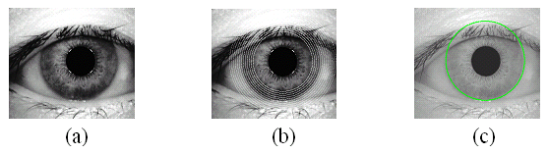
Figure (a) Contrast enhanced image , (b) Concentric circles of different radii,
(c) Localized Iris image
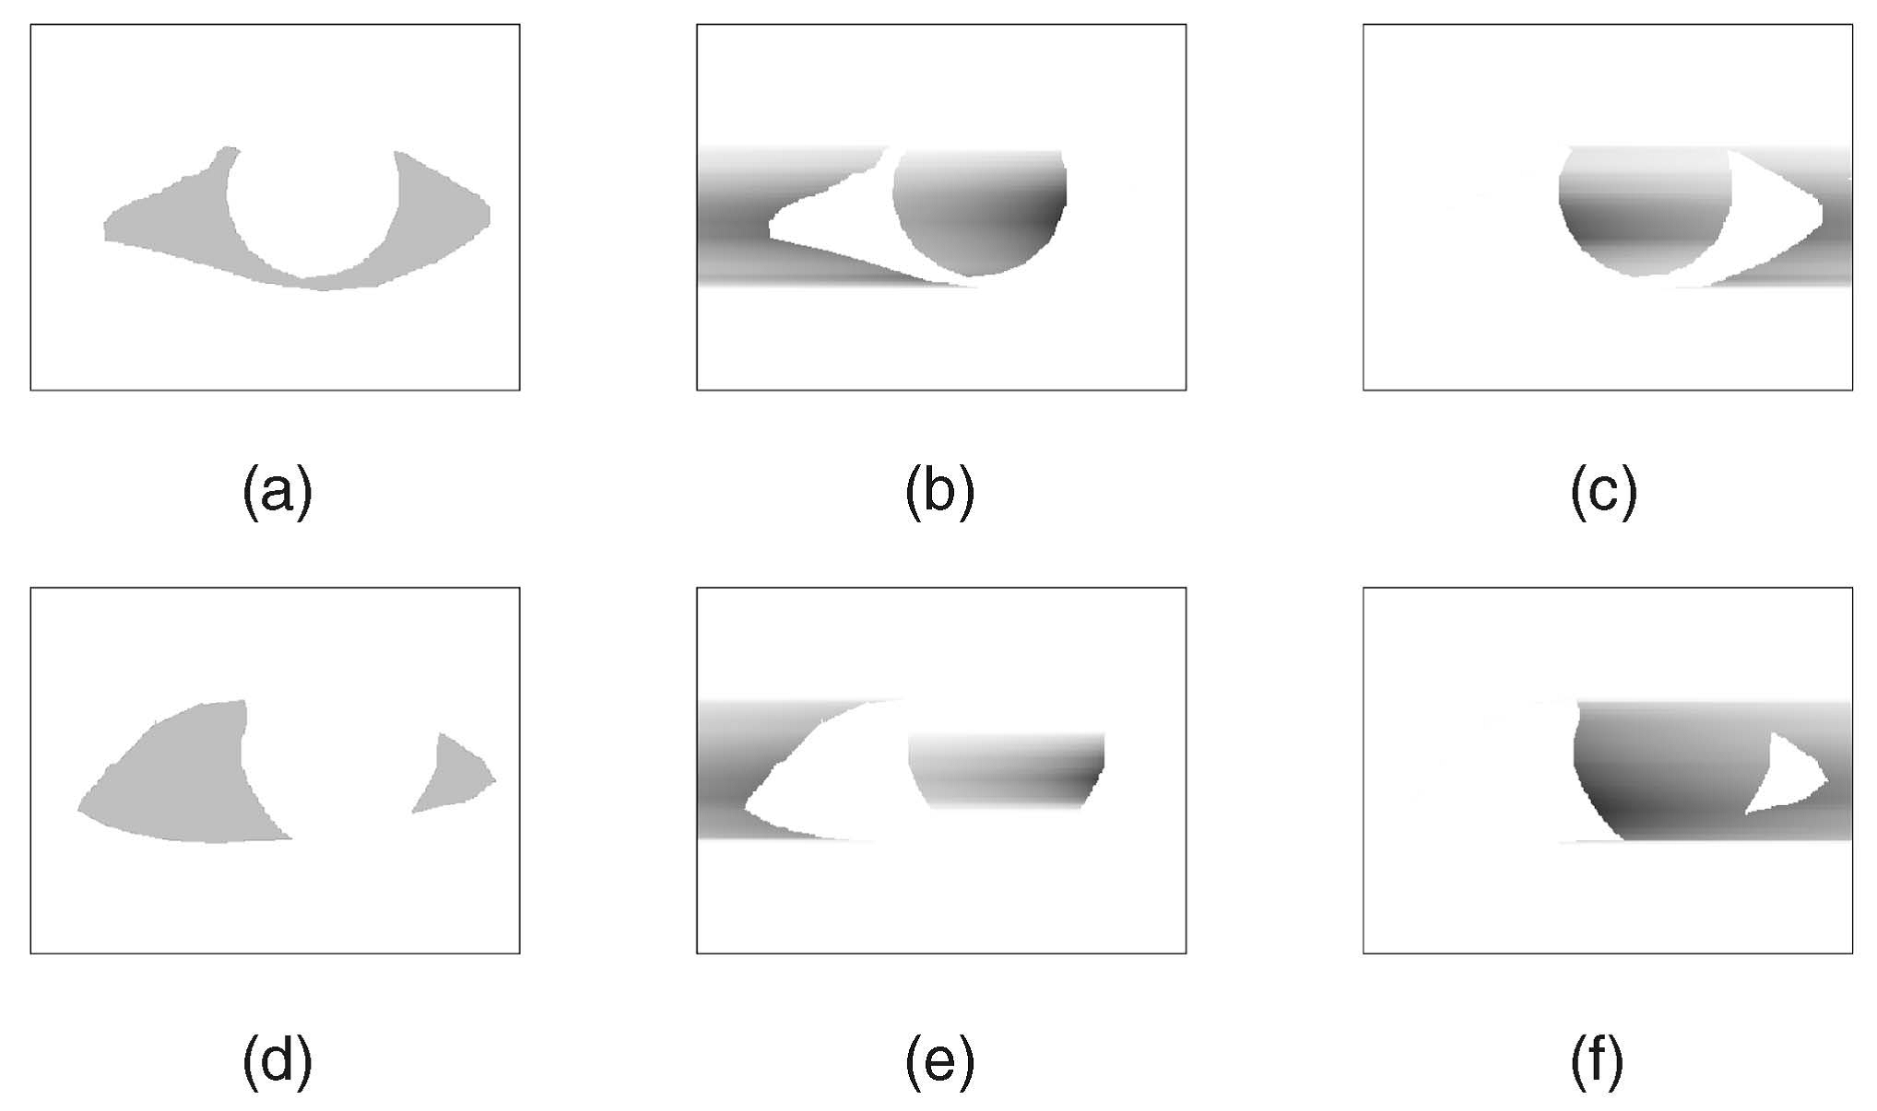
6.4 IRIS NORMALIZATION
Localizing iris from an image delineates the annular portion from the rest of the image. The concept of rubber sheet modal suggested by Daugman takes into consideration the possibility of pupil dilation and appearing of different size in different images. For this purpose, the coordinate system is changed by unwrapping the iris and mapping all the points within the boundary of the iris into their polar equivalent as shown in Figure A. The mapped image has 80 × 360 pixels. It means that the step size is same at every angle. Therefore, if the pupil dilates the same points are picked up and mapped again which makes the mapping process stretch invariant [9]. Thus the following set of equations are used to transform the annular region of iris into polar equivalent

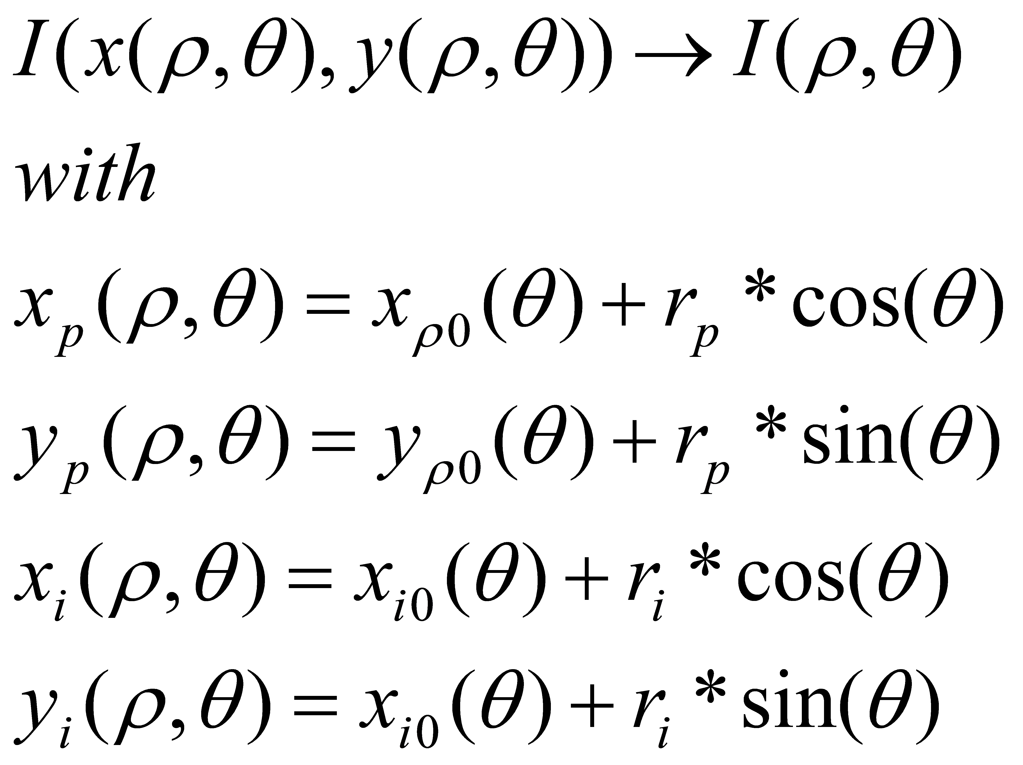
Figure a

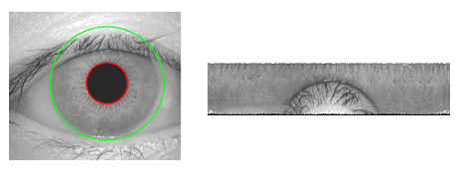
where rp and ri are respectively the radius of pupil and the iris, while (xp(θ), yp(θ)) and (xi(θ), yi(θ)) are the coordinates of the pupillary and limbic boundaries in the direction θ. The value of θ belongs to[0;2], ρ belongs to [0;1].

Figure b Iris normalization
6.5 FEATURE EXTRACTION AND MATCHING
In order to provide accurate recognition of individuals, the most discriminating information present in an iris pattern must be extracted. Only the significant features of the iris must be encoded so that comparisons between templates can be made. The template that is generated in the feature encoding process will also need a corresponding matching metric, which gives a measure of similarity between two iris templates. This metric should give one range of values known as intra-class comparisons, when comparing templates generated from the same eye and another range of values, known as inter-class comparisons when comparing templates created from different irises. These two cases should give distinct and separate values, so that a decision can be made with high confidence as to whether two templates are from the same iris, or from two different irises.
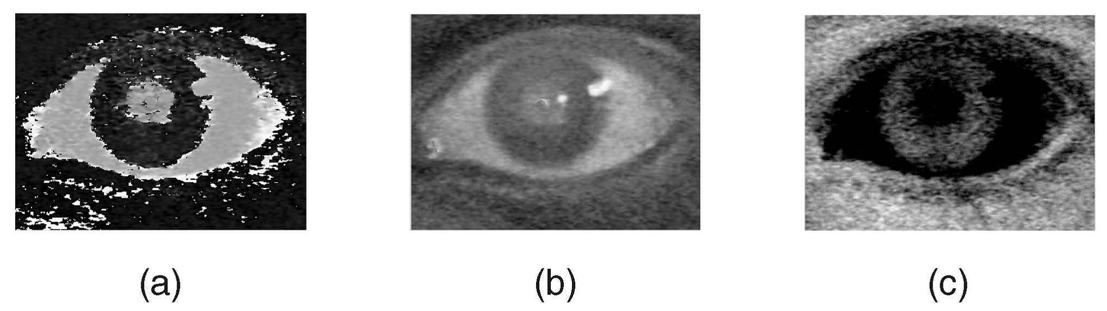
Fig. Discriminating between the regions that belong to the sclera and all the remaining types of information given by the (a) hue, (b) blue chroma (blue—luminance), and (c) red chroma (red—luminance) color components.

6.6 OBSERVATION
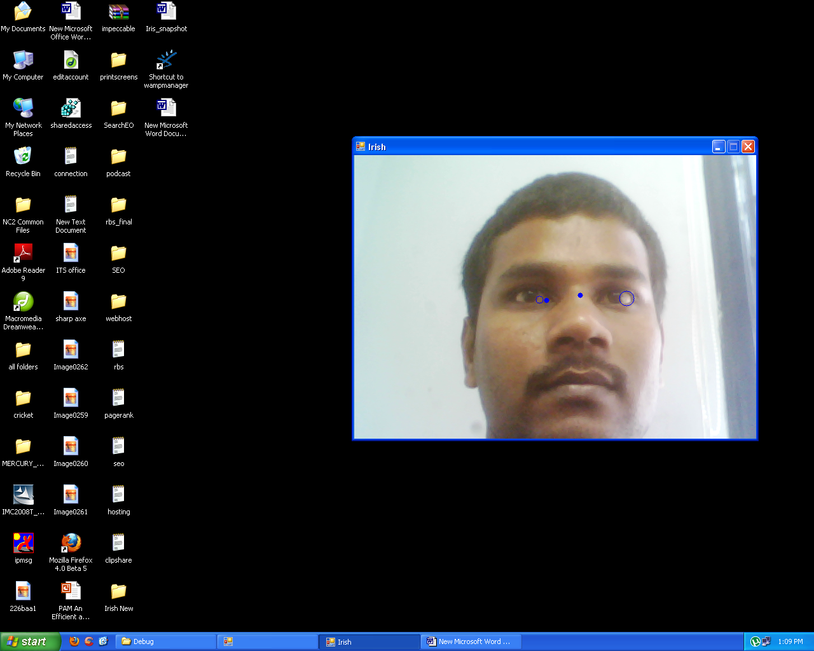

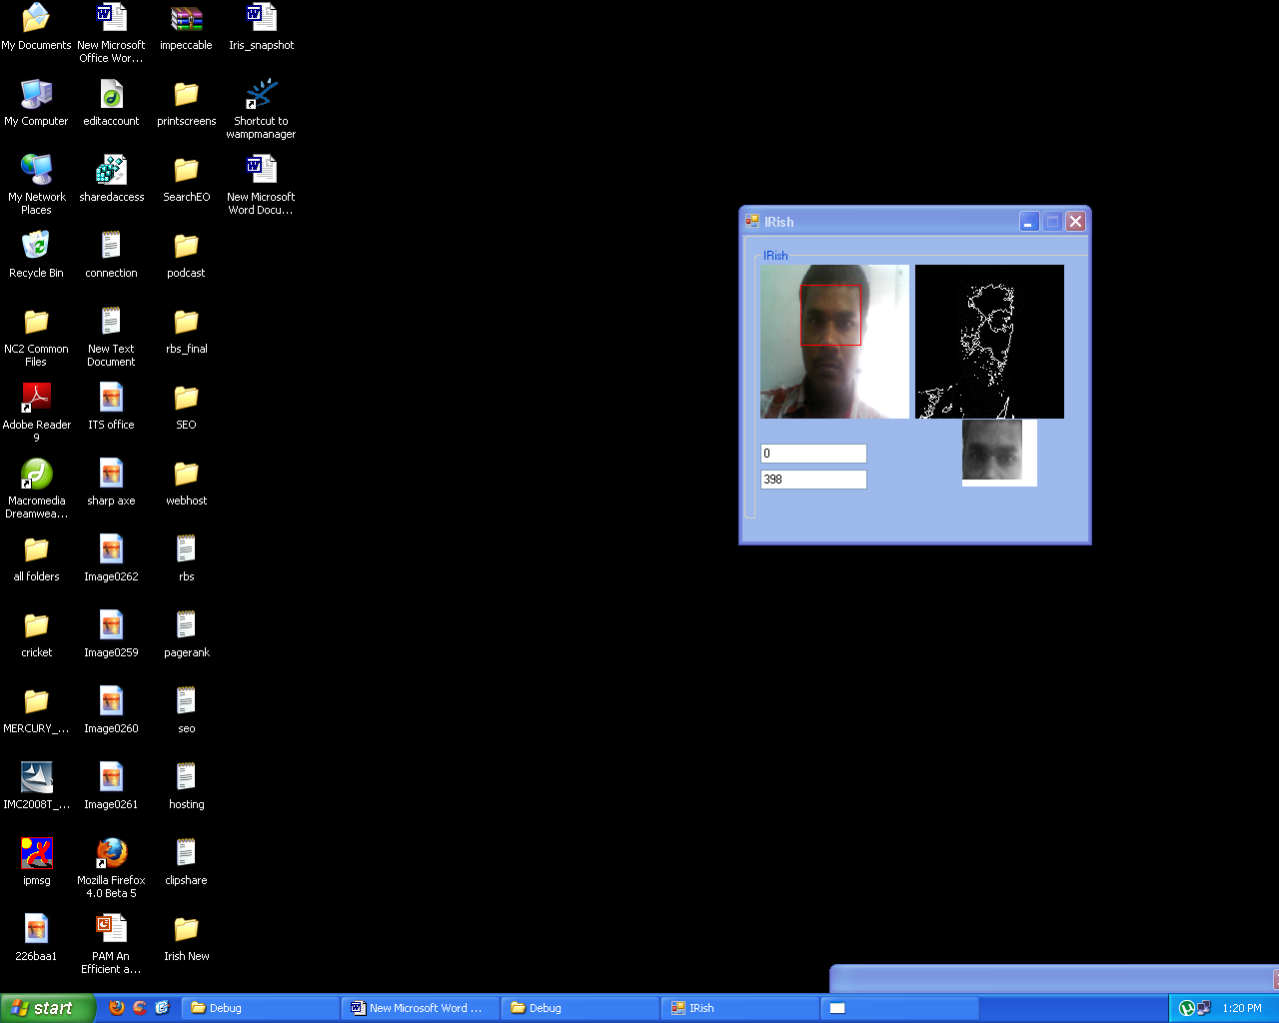


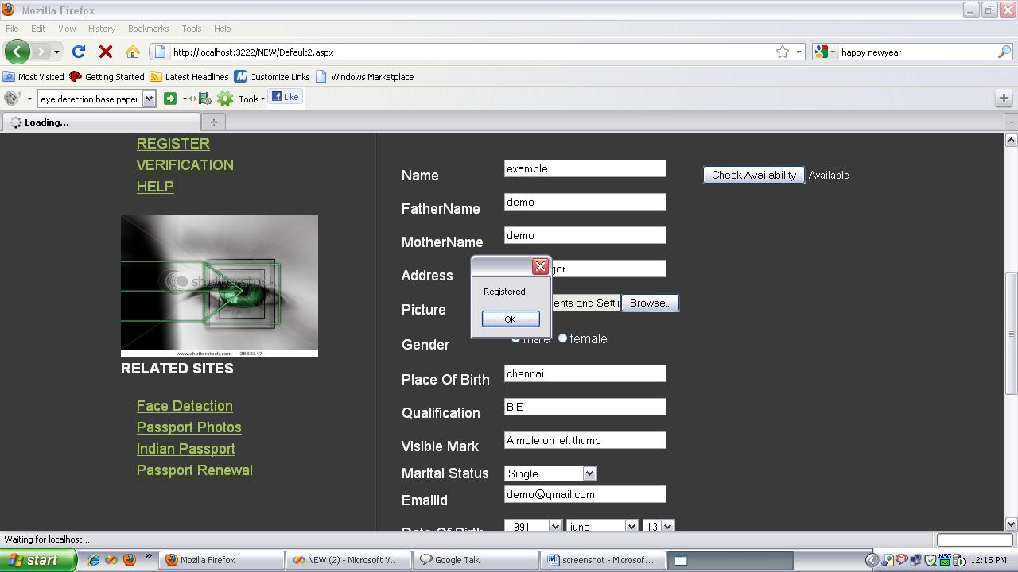

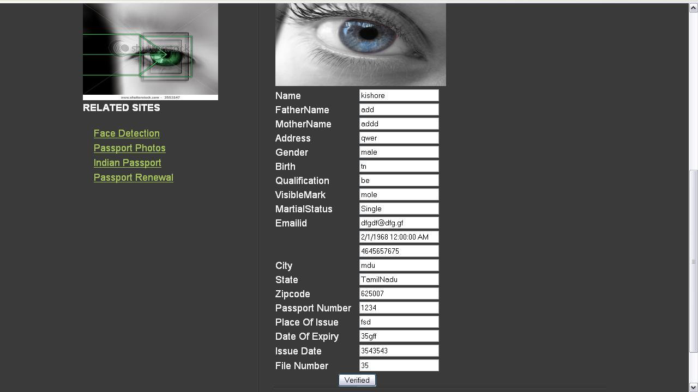
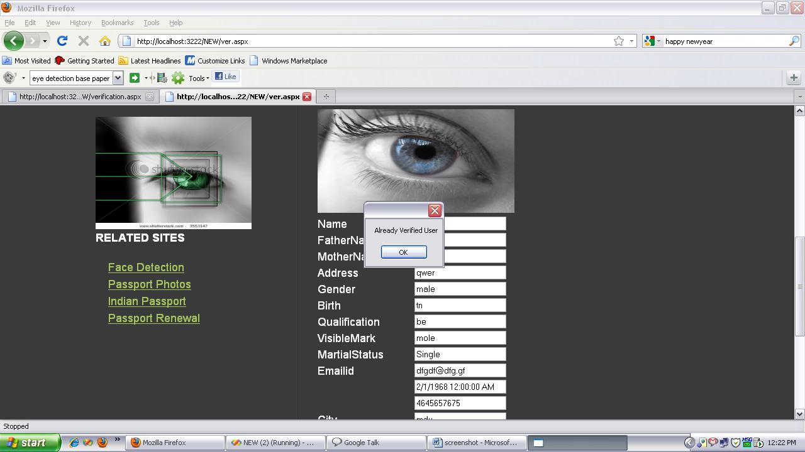
6.7 CONCLUSIONS

Due to favorable comparisons with other biometric traits, the popularity of the iris has grown considerably and efforts are concentrated in the development of systems that are less constrained to subjects, using images captured at-a-distance and on-the-move. These are extremely ambitious conditions that lead to severely degraded image data, which can be especially challenging for image segmentation. Our method encompasses three tasks that are typically separated in the literature: eye detection, iris segmentation, and discrimination of the noise-free iris texture. Our key insight is 1) to consider the sclera as the most easily distinguishable part of the eye in the case of degraded images and 2) to exploit the mandatory adjacency between the iris and the sclera to propose a new type of feature (proportion of sclera) that is fundamental in the localization of the iris, through a machine learning classification approach. Finally, a constrained polynomial fitting procedure that naturally compensates for classification inaccuracies parameterizes the pupillary and scleric iris borders. Due to performance concerns, we aimed to preserve the linear and deterministic computational complexity of our method, offering the ability to handle real-time data. We conclude that, using a relatively small set of data for learning, our method accomplished its major goals and achieved acceptable results when compared with other state-of-the-art techniques at significantly lower computational cost.

REFERENCES
- Guodong Guo, Micheal J. Jones, “Iris extraction based on Intensity Gradient and Texture Difference”, IEEE Workshop on Applications of Computer Vision, pp. 1-6, 2008.
- Karen Hollingsworth, Sarah Baker, Sarah Ring, Kevin W. Bowyer and Patrick J. Flynn, “Recent research results in iris biometrics”, Proceedings of the SPIE, Vol. 7306, pp. 73061Y-73061Y-10, 2009
- Multispectral Iris Recognition Analysis: Techniques and Evaluation By Christopher K. Boyce Keywords: Iris, Iris Recognition, Multispectral, Iris Segmentation, Spoong, Iris Anatomy, Iris Feature Extraction 2006 Christopher K. Boyce
- Novel Biorthogonal Wavelet based Iris Recognition for Robust Biometric System
- International Journal of Computer Theory and Engineering, Vol. 2, No. 2 April, 2010
- Iris Recognition Michael Boyd Dragos Carmaciu Francis Giannaros Thomas Payne William Snell March 19, 2010
- Iris Recognition Using Learning-Based Approaches by Guodong Guo at the UNIVERSITY OF WISCONSIN–MADISON 2006
- H. Proenca, S. Filipe, R. Santos, J. Oliveira, and L.A. Alexandre, “The ubiris.v2: A database of visible wavelength images captured on-themove and at-a-distance”, IEEE Transactions on Pattern Analysis and Machine Intelligence, vol. 99, no. RapidPosts, 2009.

